Hospital Management System – Project Report

Cover page
Project Title: Hospital Management System
Course: CSE1021
Submitted By: Aditya Prakash
Submitted To: Hemalakhmi
Date: 23 Nov 2025

2. Introduction
The Hospital Management System is a lightweight Python-based console application designed to streamline basic administrative operations within a hospital. It enables the admission, searching, viewing, and discharging of patients efficiently using a structured and interactive interface.

3. Problem Statement
Hospital administrative tasks often involve manual data entry, physical record maintenance, and time-consuming search processes. This project aims to simplify patient management by providing a digital solution that allows easy handling of patient records.

4. Functional Requirements
- Admit Patient – Add a new patient with ID, name, age, disease, and date.
- View Patients – Display a list of all admitted patients.
- Search Patient – Retrieve details of a specific patient using the patient ID.
- Discharge Patient – Remove a patient’s records from the system.
- Exit System – Terminate the application.

5. Non-functional Requirements
- Usability: Easy-to-use command-line interface.
- Performance: Quick lookup and update operations using an in-memory dictionary.
- Reliability: Ensures unique patient IDs and prevents duplicate entries.
- Portability: Runs on any system with Python installed.
- Maintainability: Clear structure for easy updates or feature expansion.

6. System Architecture
+---------------------------+
| User Interaction |
| (CLI - Command Line App) |
+------------+--------------+
|
v
+---------------------------+
| HospitalManager Class |
| - stores patients |
| - handles operations |
+------------+--------------+
|
v
+---------------------------+
| Data Storage Layer |
| (Dictionary in Memory) |
+---------------------------+

7. Design Diagrams

Use Case Diagram
+-------------+
| Admin |
+-------------+
/ | \
/ | \
Admit Patient | Search Patient
View Patients \
Discharge Patient

Workflow Diagram
Start
|
Display Menu
|
[User Input]
|
+-----------------------------+
| 1: Admit Patient |
| 2: View Patients |
| 3: Search Patient |
| 4: Discharge Patient |
| 5: Exit |
+-----------------------------+

Sequence Diagram
User -> System: Select Action
System -> System: Process Request
System -> User: Display Output

Class/Component Diagram
+-------------------------+
| HospitalManager |
+-------------------------+
| - patients: dict |
+-------------------------+
| + admit_patient() |
| + view_patients() |
| + search_patient() |
| + discharge_patient() |
+-------------------------+

ER Diagram (if storage used)
(Dictionary-based storage; simple key-value model)
Patient (Entity)
-----------------
PatientID (PK)
Name
Age
Disease
AdmitDate

8. Design Decisions & Rationale
- Dictionary-based storage chosen for simplicity and fast lookups.
- Command-line interface used for easy user interaction.
- Modular class-based architecture for better maintainability.

9. Implementation Details
The system is implemented entirely in Python using: - The time module for generating admission dates. - A central HospitalManager class to handle operations. - A main loop to interact with the user.

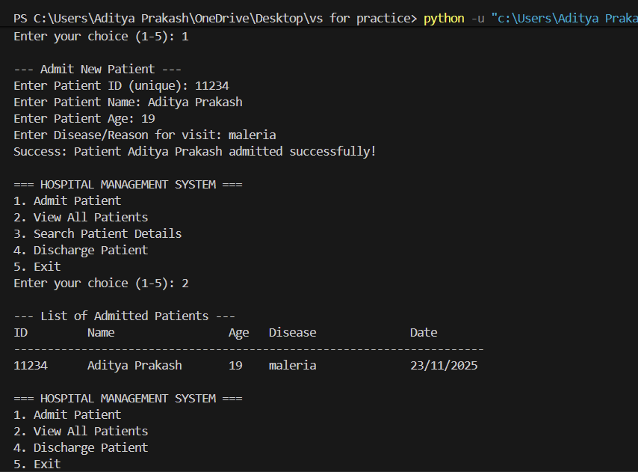
10. Screenshots / Results
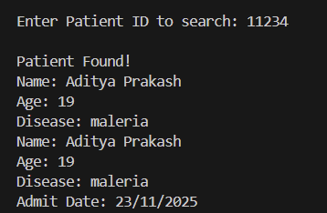
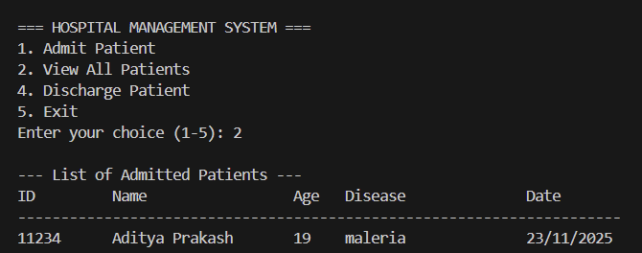

11. Testing Approach
- Manual Testing performed for each function:
  - Different patient IDs
  - Duplicate ID checks
  - Search for non-existing patients
  - Discharging logic validation
  - Boundary cases such as empty lists

12. Challenges Faced
- Ensuring uniqueness of patient IDs.
- Handling input validation.
- Ensuring readability and modularity of the code.

13. Learnings & Key Takeaways
- Learned the importance of structured data storage.
- Understood the role of modular class design.
- Improved debugging and logical thinking skills.

14. Future Enhancements
- Add persistent storage using files or databases.
- Implement GUI using Tkinter or PyQt.
- Add authentication for secure access.
- Include advanced search and filtering.
- Create reports and export data.

15. References
- Python Official Documentation
- Object-Oriented Programming Concepts
- Various online tutorials and resources

